Yaw Ofosu Ansong (Snr)

SM/SMS/09/0029

EXPERIMENT 10

AN EXPERIMENT TO DETERMING THE COEFFICIENT OF CUBICAL EXPANSION OF LIQUID USING SPECEFIC GRAVITY BOTTTLE.

27th SEPTEMBER, 2009

Title: An Experiment to determine the coefficient of cubical expansion of liquid using specific gravity bottle
Aim: To determine the co-efficient of cubical expansion of liquid using specific gravity bottle.
Apparatus: Specific gravity bottle with a well fitted stopper, glycerine, water bath, clamp and stand, thermometer, cotton thread.
Diagram
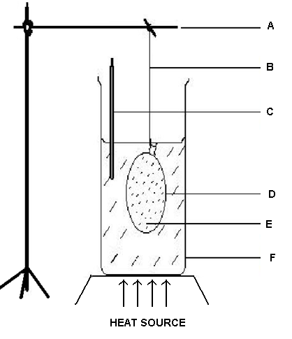
A – Clamp and stand D – Specific gravity bottle with stopper
B – Cotton thread E - Glycerine
C - Thermometer F – Water bath

Theory
The coefficient of cubical expansion of a solid is defined as the change in volume per unit initial volume per unit change in temperature. It can also be defined as the fraction of its original volume by which the solid expands per degree rise in temperature.
A change in volume occurs when a gas/liquid undergoes temperature change. A similar phenomenon occurs for solids as well. A simple approximate relation governs the thermal expansion in length, Δl, of most solids: β is the coefficient of linear expansion.
A comparison analysis applied to a solid of isotropic material demonstrates that the coefficient of volume expansion is, α=3β. The expression is given by:
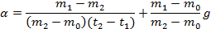
Where,

α= absolute coefficient of cubical expansion of glycerine.
m₀ is mass of the container
m₁ is mass of container + liquid before heating
m₂ is mass of the container + liquid, after heating
t₁ is the initial temperature of the liquid
t₂ is the final temperature of the liquid
g is the coefficient of cubical expansion of the container

Procedure
The specific gravity bottle was rinsed with methylated spirit. It was allowed to dry by blowing air into it. The mass of the bottle with its stopper was weighed by placing it on an analytical balance and recording the value. The stopper was then filled with glycerine from a beaker and the temperature of the glycerine in the beaker was recorded and the outside of the bottle was wiped with a filter paper. With the stopper inserted again, the mass of the glycerine in the beaker was recorded taking care to handle the bottle as little as possible to avoid warming. Some cotton thread was tied securely round the neck of the bottle and the bottle was suspended from the clamp such that it was almost completely immersed in the water bath. The water-bath was then heated and the water allowed boiling for some time. The temperature of the boiling water was taken. The bottle was removed from the boiling water, wiped thoroughly, allowed to cool and reweighed.

OBSERVATION TABLE
Mass of empty bottle, m₀ (±10⁻⁶kg) | 0.029882
Mass of bottle + stopper at t₁, m₁(±10⁻⁶kg) | 0.092998
Mass of bottle + stopper after cooling, m₂ (±10⁻⁶kg) | 0.090584
Initial temperature of glycerine, t₁(±1°C) | 28
Final temperature of boiling water, t₂(±1°C) | 95

CALCULATIONS

From the theory,

Substituting the experimental values into it,

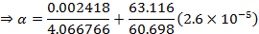

Discussion
The coefficient of cubic expansion of glycerine was determined to be 6.17×10⁻⁴K⁻¹. This means that the glycerine expanded by a factor of 0.04 per Kelvin rise in temperature. This is what made it possible for the glycerine to spill out of the specific gravity bottle: its expansion is many times greater than that of the specific gravity bottle, so some has to spill out.

Errors
1)

Precautions

1) I handled the specific gravity bottle as little as possible to avoid warming it.
2) The experiment was repeated and the average of the apparent expansivitiy of the liquid was determined in order to avoid random errors.

Conclusion
The coefficient of cubic expansion of glycerine was found to be 6.17×10⁻⁴K⁻¹.

Reference:
SERWAY A. Raymond, Faughn S. J. (2005) College physics. Thomson Learning Inc. USA. Page 313.

